**Basics of Signals**

Table of Contents

Analogue and Digital Signals 2

Sinusoidal Signals 3

Time Period 3

Amplitude 4

Angular Measurement 5

Phases 5

Equation 6

Rectification 7

Half-Wave Rectification 7

Charging a Battery with a Half-Wave Rectifier 8

## Analogue and Digital Signals

Signals can be divided into two categories, analogue and digital. Analogue signals have an infinite number of values, i.e. they can take absolutely any value within their range. Digital signals have a few specific values within their range. They cannot attain a value in between those specific values.



An analogue signal is not necessarily always a graph. We can say that the changes in temperature throughout the day form an analogue signal, or our physical movements form an analogue signal. By this, we mean that such things could be translated to a signal that would form an analogue signal.

## Sinusoidal Signals

Analogue signals could have aperiodic properties, meaning they do not follow any pattern. An example is the graph we saw above. A sinusoidal signal on the other hand, is one that does have a specific pattern. It repeats this pattern over a specific period of time.



### Time Period

The time required for one complete loop of the pattern to form is called its time period, .

Another property is the frequency, , which is the number of complete loops that a wave manages to form per unit time.

### Amplitude

The amplitude of a sinusoidal wave is the maximum value attained by the wave. It is possible for two waves to have the same frequency, but different amplitudes.



The amplitude also gives us an indication of the energy possessed by the wave. Waves with higher amplitudes have more energy.

Similarly, they could also have the same amplitude but different frequencies.



### Angular Measurement

Sinusoidal waves can be expressed using angular measurements.

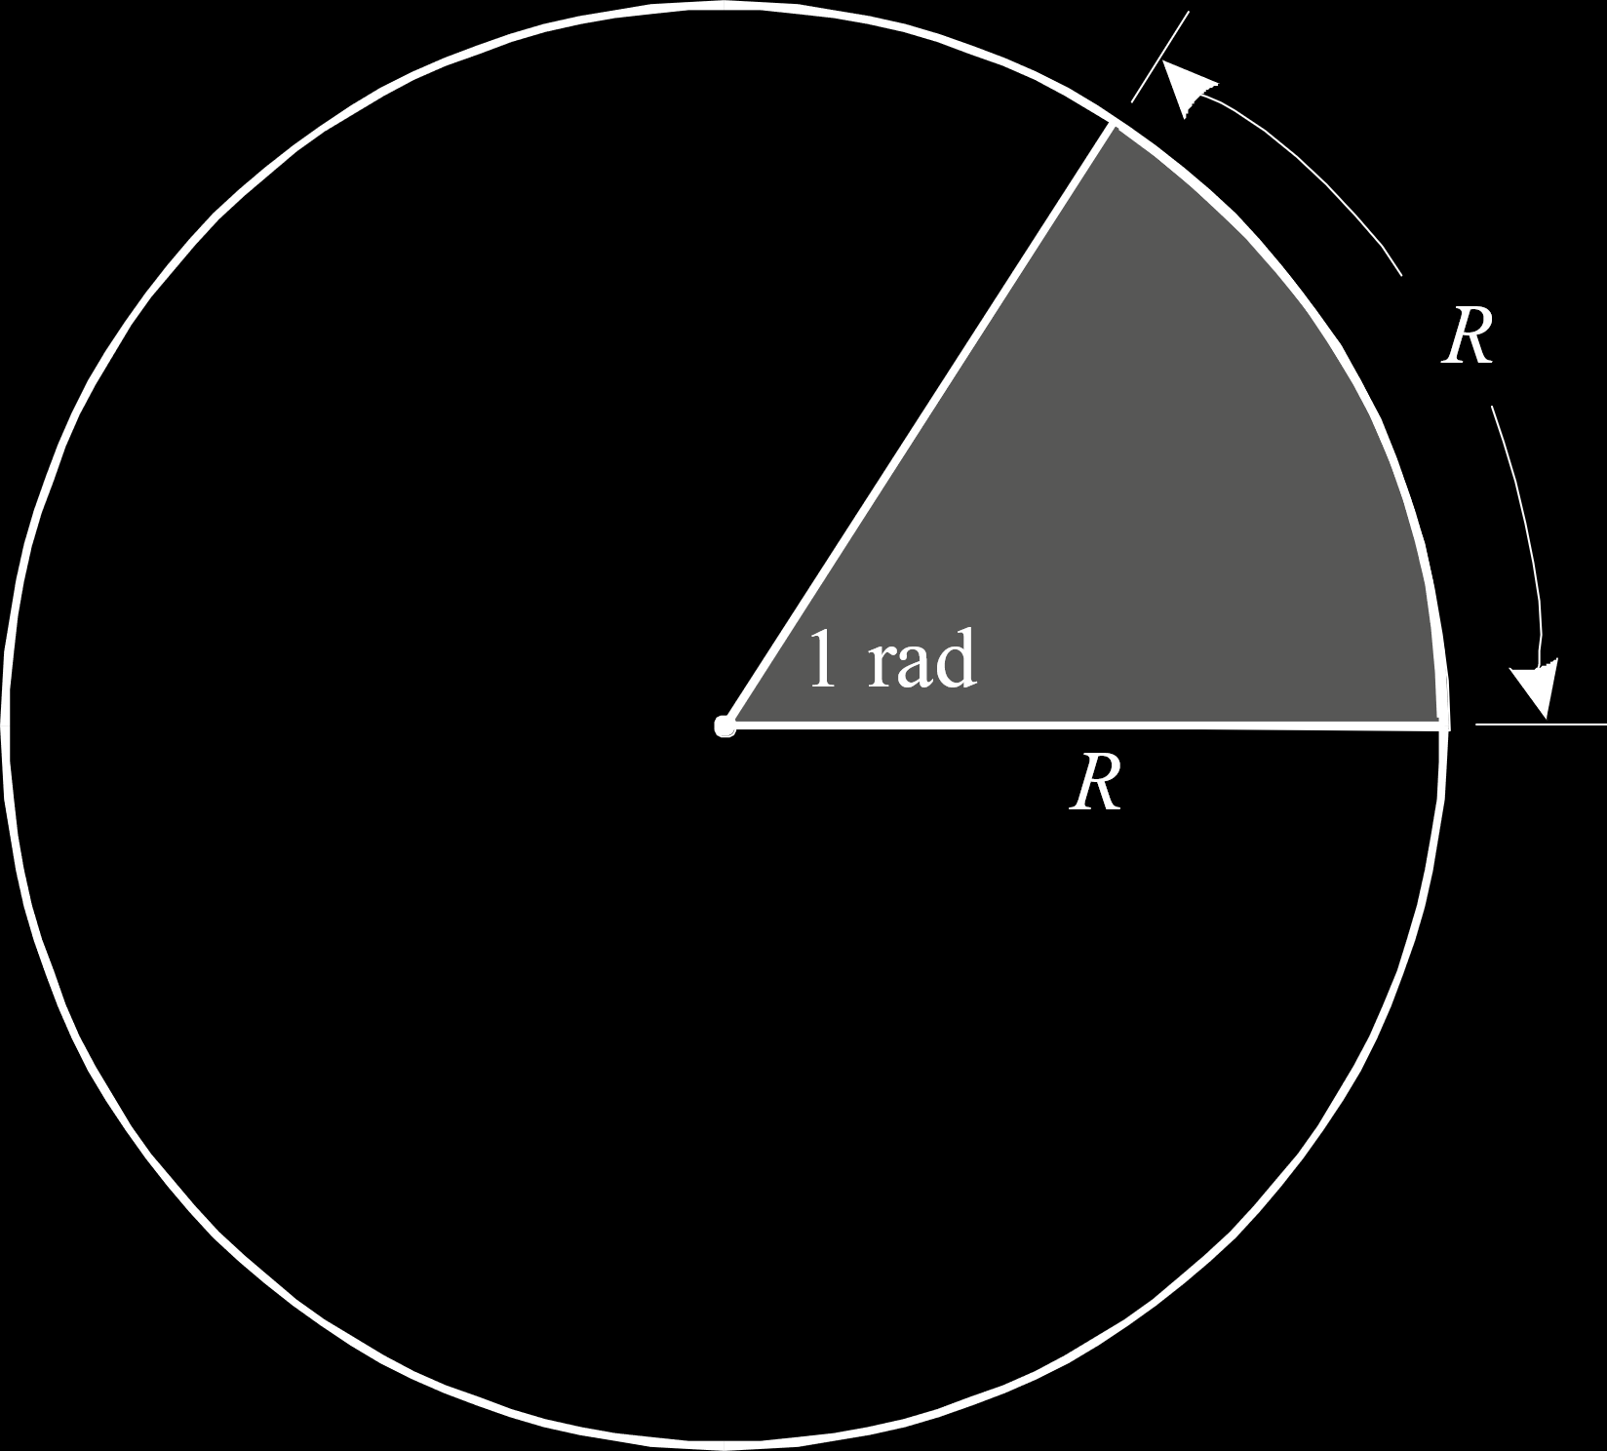 

### Phases

The phase of a signal is its offset from the origin of the graph, or the angular measurement at which it begins.



### Equation

Instantaneous values of a wave are represented as for instantaneous voltage and for instantaneous current.

## Rectification

### Half-Wave Rectification

Half-wave rectification is achieved with the help of a diode. A diode only allows movement of a signal in one direction, thus discarding the part of the signal that goes in the other direction.



Notice that in an actual diode, the peak value is not , but rather a little blow it. The same would happen in the negative direction, with the output not being cut-off at exactly .

### Charging a Battery with a Half-Wave Rectifier

It is possible to use an AC source to charge a DC battery by using a diode to remove the negative part of the current.



The resistor is a part of the circuit so that it can limit the maximum current flowing through the circuit. Too large a current could damage the circuit.